NOTE TOP ADDITIONAL COST PROJECT:

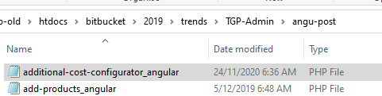

Change DEV to Live DB below

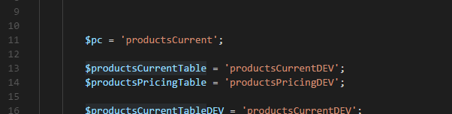



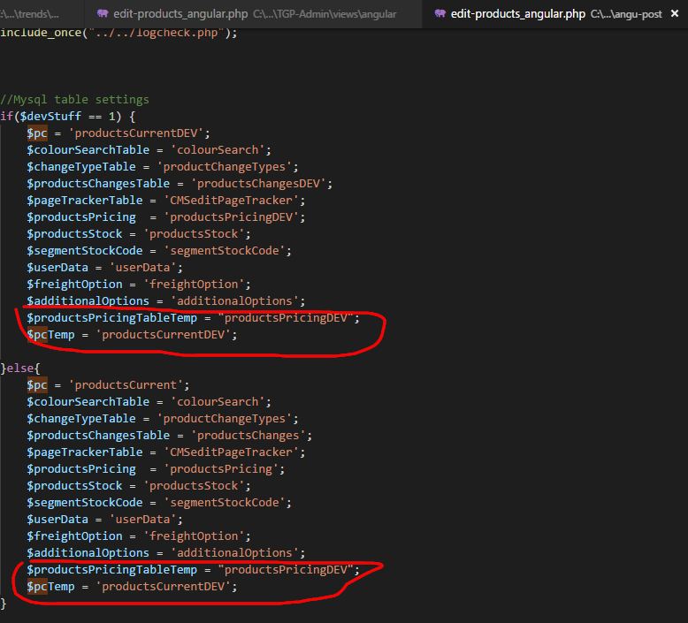

Additional cost PHP Post changes:

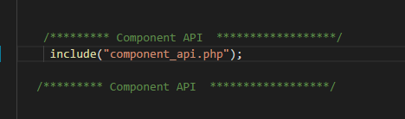

**FILES FOR Product Edits UPGRADE:**

Controller, model, index, header, custom.css

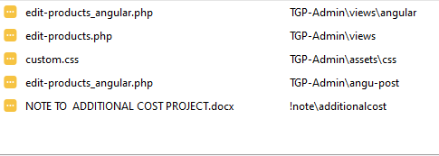



Or

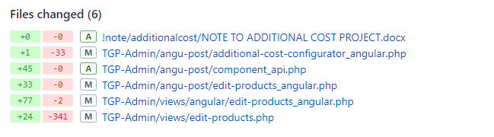

CMS access

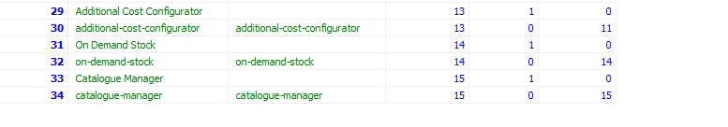

**New changes Additonal Branding**

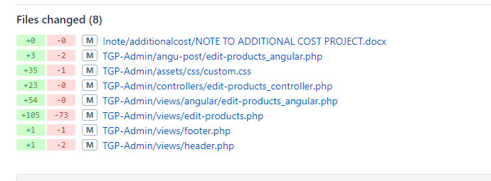

# On the Front Page

**Items page:**















Details on item page:

**Productsdisplay_model.php**

Change the additionalOptionsTemp value to = “additionalOptions”

Additional on items page

**Popup.php**

**Categories and Homepage**





# SEARCH BRANDING











# Branding Updates Display



# Visual Type

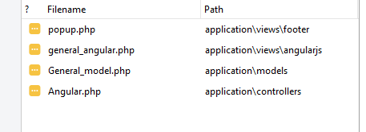

# OG:

**Header.php**

# Small Tasks:

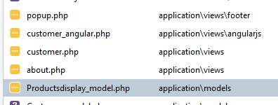

Popup changes



Icons label



# Visual Form 2D and 3D

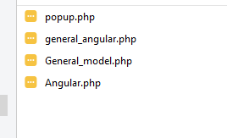





# Price Log Changes

Make the Table ChangesLog DEV to LIVE if necessary

